Decision Making using Soft Set and Rough Set on Intuitionistic Fuzzy Approximation Space

Aditi Acharjya   
*School of Computer Science & Engineering*  
*Vellore Institute of Technology*Vellore, India  
aditi.acharjya2024@vitstudent.ac.in

Tanmay Borse  
*School of Computer Science & Engineering*  
*Vellore Institute of Technology*Vellore, India  
tanmay.chhotuborse2024@vitstudent.ac.in

A Geetha Mary  
*School of Computer Science & Engineering*  
*Vellore Institute of Technology*Vellore, India  
geethamary@vit.ac.in Arpit Madse  
*School of Computer Science & Engineering*  
*Vellore Institute of Technology*Vellore, India  
arpit.shrirammadse2024@vitstudent.ac.in

*Abstract*—Data analysis and decision-making skills need to advance in the current computing era. The majority of our tools are exact, deterministic, and incisive. However, there are uncertainties in most real-life circumstances. Numerous theories, including fuzzy sets, rough sets, rough sets on intuitionistic fuzzy approximation spaces, etc., have been established to address such ambiguities. However, each of these hypotheses has drawbacks of its own. The idea of a soft set is presented in order to get around the restrictions. However, if the information system's properties are nearly same rather than exactly the same, the soft set also fails. In this research, we present a decision making model that consists of two processes such as pre-process and post-process to extract decisions. Rough set on intuitionistic fuzzy approximation spaces are used in pre-processing to obtain nearly equivalent classes, whereas soft sets are used in post-processing for decision-making. The results of testing the suggested model on an institutional dataset demonstrate the research's practicality.

Keywords—decision making, soft set, almost indiscernibility, rough set, intuitionistic fuzzy tolerance, ordering relation

# Introduction

In the current era of the internet, a vast amount of data is accessible in many different fields. Because of this, it is extremely difficult to glean meaningful information from the vast amount of data that exists in the universe. Thus, among the most prominent fields of study in recent years have been decision making, knowledge representation, and information retrieval. One of the key elements of an information system is knowledge acquisition and information retrieval. Additionally, using information at the appropriate time and location gives you a competitive edge. As a result, data analysis tools for knowledge acquisition and decision making require improvement. The majority of our conventional tools are exact, deterministic, and incisive. However, a lot of real-world issues that arise from engineering, economics, and social science are not necessarily clear-cut with an abundance of uncertainties. Consequently, the existence of uncertainty precludes the application of classical approaches. Numerous mathematical modeling methods are being developed to address uncertainty in real-world tasks. The theory of probability, fuzzy sets [1], intuitionistic fuzzy sets [2], rough sets [3], fuzzy rough sets, and rough fuzzy sets [4], as well as rough sets on fuzzy approximation spaces and intuitionistic fuzzy approximation spaces [5], are some of the key theories that address uncertainty. Further, discovery of the influencing elements that affects the decisions and helps in knowledge mining are studied [6]. In order to identify important process areas for the creation of high-quality education, a novel capacity maturity decision making model based on rough computing is presented [7]. In order to predict missing associations, a prediction model utilizing Bayesian classification and rough computing is developed [8]. Likewise, information entropy and rough computing are used to analyze the performance of educational institutions [9]. Similarly, several methods of information retrieval in knowledge discovery databases utilizing rough computing are also examined [5]. However, each of these hypotheses has drawbacks of its own. Molodstov introduced the idea of soft set theory as a mathematical method for handling uncertainty in order to get around these limitations [10].

Soft Set is a data mining technique facilitates decision-making. However, it has some constraints. An application of soft sets to a decision-making problem was presented in the literature [11]. An information system , where *U* is a set of objects and *E* is a set of parameters, is considered in this application. According to their reasoning, an item can only be a part of a parameter if it completely satisfies it. On the other side, the object does not belong to the parameter if it does not satisfy it. As a result, the parameter value can only be between 0 and 1. However, it is frequently noted that an information system is quantitative rather than qualitative in real-world scenarios [12]. For a given parameter, objects are hence almost identical rather than exactly the same. It suggests that an object may only partially satisfy a parameter rather than completely. However, they did not account for this feature in their study [11]. We suggest a decision-making paradigm with two processes, such as pre-process and post-process, to get over this constraint. In pre-processing, we find the nearly equivalence of objects given a parameter using rough sets on intuitionistic fuzzy approximation spaces. To get decisions in post-process, we employ soft set approaches. The primary benefit of the suggested paradigm is its ability to function well with both qualitative and quantitative data.

The remainder of the article is structured as follows: The rough set on intuitionistic fuzzy approximation space that determines the nearly equivalence of objects for a parameter is covered in Section II. The principles of soft set approaches are clarified in Section III. In Section IV, we introduce the suggested decision-making model. In Section V, we conduct an empirical investigation to evaluate the model. Section VI concludes the article.

# Rough Set on Intuitionistic Fuzzy Approximation Space

In this section of the article, we delineate the definitions, concepts, and findings related to rough sets within the context of intuitionistic fuzzy approximation spaces. For membership and non-membership functions related to an intuitionistic fuzzy set, we use the conventional notation  and , respectively.

Let *Z* be the universe of a finite collection of items that are not empty. An intuitionistic fuzzy relation on *Z* is an intuitionistic fuzzy subset of . An intuitionistic fuzzy proximity relation *R* on *Z* is an intuitionistic fuzzy proximity relation that satisfies the condition  for all  and  for all  [13].

Let . Then the -cut of *R* is given as , and is defined as . Two objects  are said to be - similar concerning *R* if  and is denoted as  . Likewise, two objects  are said to be - identical concerning *R* if  or  is transitively - similar to  and we write . Thus, generates an equivalence relation. Hence,  generates an approximation space,  , known as intuitionistic fuzzy approximation space. Given a target set, , the lower and upper approximation is defined asand respectively, where

 (1)

 (2)

If , then the target set *X* is called -crisp, otherwise it is termed as -rough. If *X* is -rough, then the boundary region is defined as  .

## Almost Indiscernibility

The universe can be thought of as an enormous number of objects. Each object has specific parameters, and the values of those parameters reveal some information about that specific object. Objects in the same information category cannot be distinguished from one another. This is the foundation of rough set theory and is referred to as indiscernibility relation. An indiscernibility relation regards all identical things in a collection as elementary. However, it has been noted in numerous real-world applications using data gathered from multiple sources that two distinct objects, xi and xj, may have parameter values that are almost equal but not precisely the same. For instance, considering the objects as patients, the symptoms of the diseases are almost equal rather exactly equal. In light of this, the intuitionistic fuzzy proximity relation is introduced, generalizing the indiscernibility relation of rough set theory to an almost indiscernibility relation.

## Information Database

One way to think of an information database is as an information table. While each column of the information system is regarded as a parameter, each row is regarded as an object. The primary goal of data mining is to categorize the items in an information database and extract knowledge from them. However, some of the data in the underlying information database is not clear and distinct in a normal real-world setting. In recent years, rough sets have emerged as the most effective technique for dealing with data ambiguity. The definition of an information database is a quadruple, where *Z* is a finite nonempty set of objects, *A* is the set of parameters,  and *f* is the information function.

For example, consider a sample information database of smart phones presented in Table 1. In the given Table,  , *A* ={Brand, Color, Storage, Price}, and = {Grey, White, Blue, Black}. The smart phone  is characterized by Brand: Apple, Color: White, Storage: 256 and Price: 65000.

1. Sample Information Database

| Smart Phones | Parameters | | |  |
| --- | --- | --- | --- | --- |
| Brand | Color | Storage (GB) | Price (INR) |
|  | Samsung | Grey | 128 | 30000 |
|  | Apple | White | 256 | 65000 |
|  | Samsung | Grey | 128 | 30100 |
|  | Motorola | Blue | 256 | 32000 |
|  | Apple | Black | 128 | 68000 |

# Rudiments of Soft Set

For several decades, the theory of soft sets [10] has been continuously developed, and a rapidly expanding number of academics are interested in this methodology. The approach is a mathematical tool for handling ambiguous, imprecise, and unclear objects. In this section, we provide an overview of the paper's background by outlining the basic ideas, symbols, and findings on soft sets [10, 11], all of which serve as the foundation for our suggested decision-making model.

Consider an universal set of objects *Z* characterized by a set of parameters *A*. Assume,  refers to the power set of *Z.* and . A pair  is termed as a soft set over *Z*, in which  is a function. Stated differently, the soft set is a parameterized subset family of universe *Z*. The set of *a* - approximate elements of the soft set  can be regarded as for . Below, we provide an example for reference.

Consider a collection of smartphones  characterized by a set of parameters *A* = {Android, Cheap, Camera, Handy, Expensive}. Assume that  . Table 2 illustrates how this can be represented as an information database.

1. Illustration of Soft Set Example

|  |  |  |  |  |  |
| --- | --- | --- | --- | --- | --- |
| Smartphone | Android | Cheap | Camera | Handy | Expensive |
|  | 0 | 1 | 0 | 1 | 0 |
|  | 1 | 1 | 1 | 0 | 0 |
|  | 0 | 0 | 0 | 1 | 1 |
|  | 0 | 0 | 1 | 0 | 1 |
|  | 1 | 0 | 1 | 0 | 0 |
|  | 0 | 0 | 0 | 1 | 0 |

In this instance, defining a soft set entails identifying expensive smartphone, handy smartphone, camera smartphone, cheap smartphone, and android smartphone. It is important to remember that for some , the sets  might be empty. In classical mathematics, an object is represented mathematically, and its exact solution is then determined. Generally speaking, mathematical models are too complex and unable to pinpoint the precise answer. As a result, we present the idea of an approximate answer and compute it as discussed in the Section IV.

We approach this problem in the opposite way in soft set theory. It is not required to introduce the concept of an exact solution because the original description of the object is approximate in nature. Soft set theory is very practical and easy to apply because it does not impose any limitations on the approximate description. But, it does have some restrictions. Consider the information database depicted in Table 2 as an example.

It is evident from Table II that an object either belongs to a parameter or doesn't. However, based on parameter values, an object in real life belongs to a parameter. For instance, one needs to be aware of the prices of smartphones in order to determine whether they are expensive or not. Let the pricing of the smartphones  be Rs. 25,600, Rs. 22,000, Rs. 43,000, Rs. 43,000, Rs. 42,900, and Rs. 42,950. The aforementioned data makes it evident that the  and  smartphones are expensive. However, it is impossible to argue that the , and  smartphones are not expensive. Therefore, when making decisions, the parameter values must be taken into account in order to determine whether an object belongs to a parameter. This serves as the rationale for the suggested decision-making paradigm that will be discussed in the following section.

# Proposed Decision Making Model

A decision-making paradigm for extracting decisions from information database is presented in this section. Figure 1 shows an abstract representation of the suggested paradigm, which includes preprocess and post-process. An information database's data is typically in a hybrid format. Either qualitative or quantitative data values are indicated. Consequently, it is necessary to transform the quantitative data into qualitative data. In preprocess, we use a rough set on intuitionistic fuzzy approximation space to process the quantitative data after it has been cleaned. The number of attributes that have no influence on the information database is further decreased by employing rough set reduction approaches. Additionally, in the post-process, soft set techniques are utilized to mine information database decisions based on the classification that was achieved in the pre-process. This model's primary benefit is that it can be applied to both qualitative and quantitative data. Furthermore, it assigns appropriate weight to data values rather than 0 and 1.

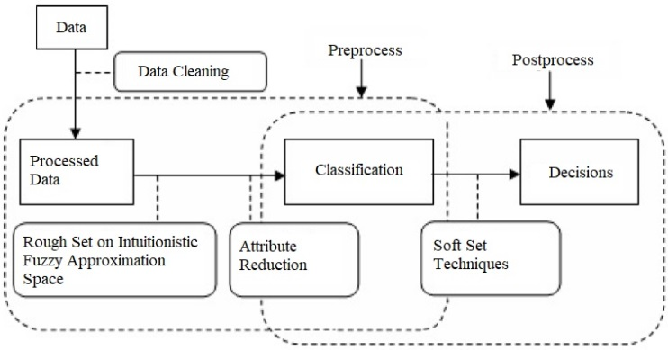

Fig. 1. Proposed decision making model

Selecting the appropriate problem is the first step in any model. The problem definition is constantly linked to the incorporation of existing knowledge. However, due to the acquisition of knowledge and reasoning that may be involved in vagueness and incompleteness, the potential validity or usefulness of a single data element or pattern of data elements may vary significantly from organization to organization. Consequently, obtaining good conclusions from the high-dimensional data is the most significant difficulty. In order to mine appropriate classification, we employ rough set on intuitionistic fuzzy approximation space reduction. Further, we extract decisions using soft set techniques based on the pre-process classification.

## Preprocess of Proposed Design

Figure 2 illustrates the preprocess architectural design in this area, which includes problem comprehension, target data, data cleaning, intuitionistic fuzzy proximity relationship, and data categorization. The foundational steps of every model include defining the problem and incorporating existing knowledge. A target dataset is then generated by organizing the goals and related factors, which will be used for decision-making. To start, a series of data cleaning procedures are carried out to make sure the data are as accurate as possible. These procedures include noise removal, consistency checks, and data completeness. As explained in Section II, intuitionistic fuzzy proximity relations are used to calculate equivalence classes for each parameter. To determine the almost indiscernibility of the objects  and , we define an intuitionistic fuzzy proximity relation concerning the membership and non-membership functions as defined below.

 (3)

 (4)

In addition to becoming symmetric, the membership and non-membership functions have been defined so that their values fall between 0 and 1. Further, -equivalence classes are induced and the almost indiscernible items are identified by the intuitionistic fuzzy proximity relation. Additionally, the information system is used for parameter reduction, which is a crucial component of the rough set. By doing this, the number of parameters may be reduced and the object categorization can meet all of the requirements. Reduction parameters have been shown to be able to eliminate unnecessary parameters and provide the decision maker with clear, concise information. Using the dependency properties of parameters, we may determine all minimal subsets of parameters that have the same number of elementary sets without compromising the reduced information system's classification power if the set of parameters is dependent [14].

Parameter reduction is a crucial component of rough computing. Reduction can reduce the number of parameters and ensure that the object classification meets all of the requirements. It has been noted in real-world applications that reduct parameters can eliminate unnecessary parameters in relation to a particular categorization produced by parameters and facilitate straightforward decision-making. Let and . If , then we say that the parameter *a* is dispensable, else is indispensable in *E*.

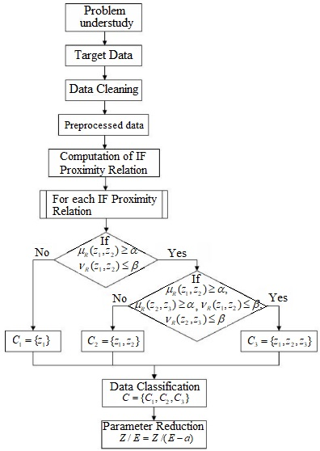

Fig. 2. Preprocess design of decision making

## Postprocess of Proposed Design

#### The application of soft set approaches to decision-making is covered in this section. The preprocessed classification serves as the postprocess's input. Let Z be the conversation universe. Let be the categorization that the parameter yields. Assume that there are q-number of equivalence classes in the categorization . Thus, we have .

#### In order to represent a soft set in a tabular form, we must compute the table's entries. Assume that there are m-objects in the classification i.e., . Calculate for every equivalence class to fill the ith parameter cells of the table, where

#### (5)

#### Calculate for each . Further, one can extract the decisions depending on the choice value from the soft set's tabular form. The choice value of an object is defined as , where are the entries in the table of soft set, and

#### (6)

#### To retrieve decisions from the information database, we now suggest a straightforward and weighted procedure. To get decisions, the following algorithm can be used.

*Algorithm 1:* (*Straightforward decision making algorithm*)

Input: Maximum range of and 

Output: Inferred decisions



It's common knowledge that decisions on the parameters of an information database might change. As a result, the factors considered when making decisions might not be equally significant. It implies that while some criteria might be regarded as low priority, others might be regarded as high priority. We apply weights to the selected parameters in order to get around this restriction. Assume the weights of parameter  be , where . Accordingly, we define below the weighted decision making algorithm for making decisions.

*Algorithm 2:* (*Weighted decision making algorithm*)

Input: Maximum range of and 

Output: Inferred decisions



# Experimental Study on Institution Ranking

To illustrate the model, a real-world application is suggested in this section. To demonstrate our suggested paradigm, we look at an information database, which is a group of institutions, and attempt to rank them. In Table III, we outline the parameter description, the notations to be used, and the range that may be possible. Institutions might not meet all the requirements to be at the top. Nevertheless, some of these characteristics might affect the score more than others. These parameters may vary for a range of  values. As the value of decreases and increases, an increasing number of factors will become essential. Furthermore, some parameters influence other parameters; hence, for each parameter, almost indistinguishable institutions are found using an intuitionistic fuzzy proximity relation. The results that are generated can be used to evaluate institutions.

The placement performance of any institution serves as an attribute for the quality of the output and it is obtained from 385 which is roughly 24% of the overall weight. A high-quality input is necessary for any institution to provide high-quality output. Any institution's primary resources for providing high-quality education are its infrastructure and intellectual capital. As a result, the infrastructure and intellectual capital scores were set at 250 and 200, respectively, representing 15% and 12% of the total weight. Following placement, the students meet the company's expectations which make the recruiter happy. It has a score of 200, or about 12%, and is an essential component of every institution. Extracurricular activities receive a score of 80 with a weight of 6% and often boost students' confidence levels. At the same time, prospective students place a high value on student satisfaction, which is assigned a score of 60 with a weight of 4%. But a lot of other factors that don't affect how the institutions are ranked aren't taken into account in this study.

The information database considered here is taken from India Today. However, all the data are not taken into account because to make the analysis simple and understandable. But, it can be ported to any size of data and is ideal for parallel processing. Besides, we have kept secret the institution names.

1. Description of Parameters

| Parameter | Representation | Possible Range |
| --- | --- | --- |
| Intellectual Capital | IC | [1-250] |
| Infrastructure | IF | [1-200] |
| Placement performance | PP | [1-385] |
| Recruiters satisfaction | RS | [1-200] |
| Students satisfaction | SS | [1-60] |
| Extra curricular activities | ECA | [1-80] |

## Preprocess of Experimental Study

The following components of the preprocess design for the experimental study under consideration are covered in detail in this section. Data from 10 institutions are taken into consideration in order to illustrate preprocess of our suggested decision making model. The notation used for representing institutions are . The information database used for analysis is produced in Table IV. Each parameter's intuitionistic fuzzy proximity relations are joined together to form - equivalence classes. The intuitionistic fuzzy proximity relations that correlate to the attributes IC, IF, PP, RS, SS, and ECA are calculated. For the parameter IC, we display the intuitionistic fuzzy proximity relation in Table V.

1. Sample Information Database

|  |  |  |  |  |  |  |
| --- | --- | --- | --- | --- | --- | --- |
| Institutions | IC | IF | PP | RS | SS | ECA |
|  | 92 | 48 | 100 | 137 | 32 | 2 |
|  | 88 | 58 | 121 | 143 | 40 | 34 |
|  | 124 | 61 | 130 | 142 | 38 | 9 |
|  | 131 | 78 | 138 | 145 | 46 | 25 |
|  | 148 | 102 | 180 | 147 | 43 | 27 |
|  | 179 | 117 | 247 | 160 | 53 | 53 |
|  | 191 | 110 | 316 | 163 | 41 | 64 |
|  | 226 | 145 | 266 | 167 | 54 | 63 |
|  | 227 | 143 | 298 | 169 | 53 | 79 |
|  | 229 | 151 | 304 | 169 | 56 | 49 |

1. Intuitionistic Fuzzy Proximity Relation of IC

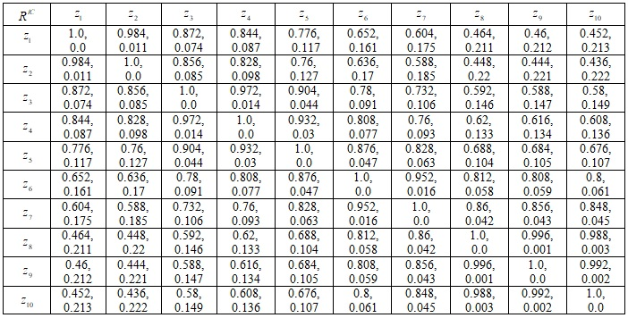

Likewise, Tables VI–X compute the intuitionistic fuzzy proximity relation for the parameters IF, PP, RS, SS, and ECA, respectively. Further, the - indiscernibility relation classification is obtained considering the membership value greater than 92% (0.92) and non-membership value less than or equal to 6% (0.06).

1. Intuitionistic Fuzzy Proximity Relation of IF

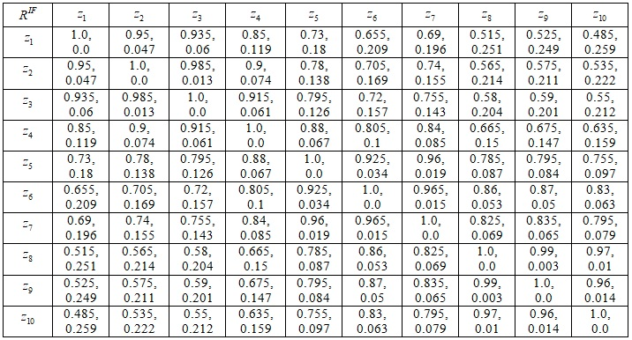

1. Intuitionistic Fuzzy Proximity Relation of PP

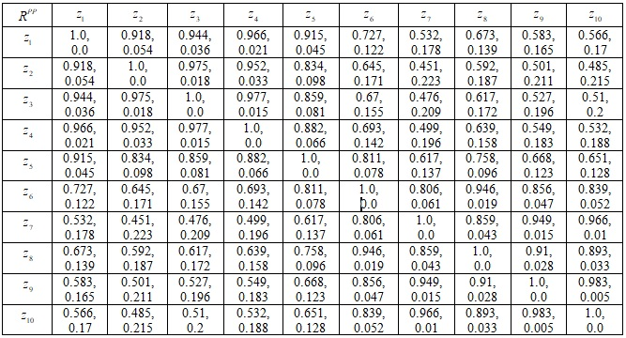

1. Intuitionistic Fuzzy Proximity Relation of Rs

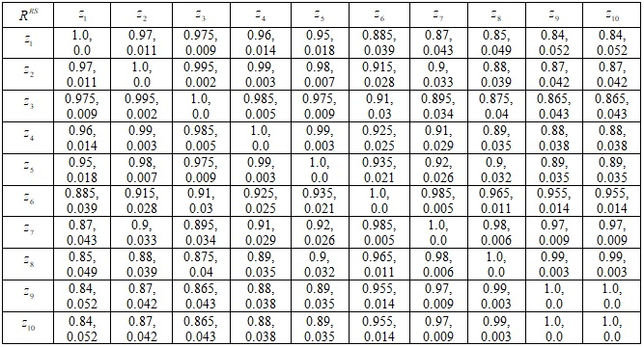

1. Intuitionistic Fuzzy Proximity Relation of Ss

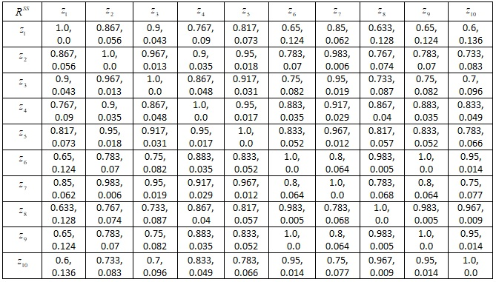

1. Intuitionistic Fuzzy Proximity Relation of Eca

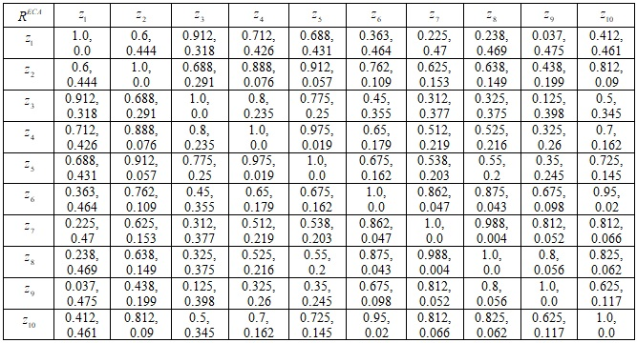

## The equivalence classes obtained for various parameters is presented below and it becomes the input to the postprocess of the research design. From the analysis, it is clear that contains only one class and hence we have . It implies that the parameter RS may be eliminated from the information database.

## 

## Postprocess of Experimental Study

Data classification can be done with soft set analysis. However, preprocessing has already classed the data. Using soft set strategies to produce effective decisions is the aim of this process. We take into consideration the classification obtained for parameter IC in order to demonstrate post-process analysis. From the above analysis it is clear that  contains four classes. Assume that, these four classes be . The value of for class is calculated below.



Likewise, the values of for classes and are computed as 0.54, 0.74, and 0.91 respectively. The computation is repeated for the entire parameters infrastructure (IF), placement performance (PP), student satisfaction (SS), and extracurricular activities (ECA) and is presented in Table XI. It is considered as a tabular representation of soft set. It is clearly seen that the objects are partially belonging to the parameters and takes value between 0 and 1.

Further, to rank the institutions based on the parameters *A* = {*IC*, *IF*, *PP*, *SS*, *ECA*}, the choice values of the institutions are computed as discussed in the straight forward algorithm 1. The choice values of all the institutions are presented in Table XII. According to the computation, the first rank belongs to the institution .

1. Soft Set Tabular Presentation

|  |  |  |  |  |  |
| --- | --- | --- | --- | --- | --- |
| Institutions | IC | IF | PP | SS | ECA |
|  | 0.36 | 0.28 | 0.32 | 0.53 | 0.02 |
|  | 0.36 | 0.28 | 0.32 | 0.69 | 0.42 |
|  | 0.54 | 0.28 | 0.32 | 0.69 | 0.11 |
|  | 0.54 | 0.39 | 0.32 | 0.69 | 0.32 |
|  | 0.54 | 0.55 | 0.47 | 0.69 | 0.32 |
|  | 0.74 | 0.55 | 0.67 | 0.9 | 0.64 |
|  | 0.74 | 0.55 | 0.79 | 0.69 | 0.79 |
|  | 0.91 | 0.73 | 0.67 | 0.9 | 0.79 |
|  | 0.91 | 0.73 | 0.79 | 0.9 | 0.99 |
|  | 0.91 | 0.73 | 0.79 | 0.9 | 0.64 |

1. Proposed Straightforward DECISION Making

|  |  |  |  |  |  |  |
| --- | --- | --- | --- | --- | --- | --- |
| Institutions | IC | IF | PP | SS | ECA | Choice  Value |
|  | 0.36 | 0.28 | 0.32 | 0.53 | 0.02 | 1.51 |
|  | 0.36 | 0.28 | 0.32 | 0.69 | 0.42 | 2.07 |
|  | 0.54 | 0.28 | 0.32 | 0.69 | 0.11 | 1.94 |
|  | 0.54 | 0.39 | 0.32 | 0.69 | 0.32 | 2.26 |
|  | 0.54 | 0.55 | 0.47 | 0.69 | 0.32 | 2.57 |
|  | 0.74 | 0.55 | 0.67 | 0.9 | 0.64 | 3.5 |
|  | 0.74 | 0.55 | 0.79 | 0.69 | 0.79 | 3.56 |
|  | 0.91 | 0.73 | 0.67 | 0.9 | 0.79 | 4.00 |
|  | 0.91 | 0.73 | 0.79 | 0.9 | 0.99 | 4.32 |
|  | 0.91 | 0.73 | 0.79 | 0.9 | 0.64 | 3.97 |

Similarly, the second rank goes to the institution and so on. As mentioned in earlier section, we now use Algorithm 2 to analyze the identical instance. Assume that the parameters of *A* = {*IC*, *IF*, *PP*, *SS*, *ECA*} are given the following weights. Assume that the weights be 40%, 50%, 90%, 30%, and 20%, respectively, correspond to the parameters IC, IF, PP, SS, and ECA. Table XIII displays the weighted choice value for each object based on the weights.

1. Proposed Weighted DECISION Making

|  |  |  |  |  |  |  |
| --- | --- | --- | --- | --- | --- | --- |
| Institutions | IC  0.4 | IF  0.5 | PP  0.9 | SS  0.3 | ECA  0.2 | Weighted Choice  Value |
|  | 0.36 | 0.28 | 0.32 | 0.53 | 0.02 | 0.735 |
|  | 0.36 | 0.28 | 0.32 | 0.69 | 0.42 | 0.863 |
|  | 0.54 | 0.28 | 0.32 | 0.69 | 0.11 | 0.873 |
|  | 0.54 | 0.39 | 0.32 | 0.69 | 0.32 | 0.97 |
|  | 0.54 | 0.55 | 0.47 | 0.69 | 0.32 | 1.185 |
|  | 0.74 | 0.55 | 0.67 | 0.9 | 0.64 | 1.572 |
|  | 0.74 | 0.55 | 0.79 | 0.69 | 0.79 | 1.647 |
|  | 0.91 | 0.73 | 0.67 | 0.9 | 0.79 | 1.760 |
|  | 0.91 | 0.73 | 0.79 | 0.9 | 0.99 | 1.908 |
|  | 0.91 | 0.73 | 0.79 | 0.9 | 0.64 | 1.838 |

According to the computation, the first rank belongs to the institution  whereas the second rank belongs to the institution. The aforementioned choice of institution complies with the selection criteria. As a result, the algorithm performs better while making decisions under a variety of conditions.

# Conclusion

A soft set is a generic mathematical technique used to solve a variety of real-world issues including ambiguous or fuzzy objects and uncertainties. According to the literature, Maji and Roy [15] combined the rough-set and soft-set techniques for decision making. However, an object in each of these models has the option of belonging to or not belonging to a parameter. As a result, the parameter values can only be 0 or 1. However, it is frequently observed in real-world problems that an object may only partially correspond to a parameter. The reason for this is because parameter values in an information database are almost identical. This restriction is removed by the suggested decision-making approach. Furthermore, the suggested model reduces to the current model if almost indiscernibility becomes indiscernibility. As a result, it works better at solving real-world problems in a variety of scenarios. In order to make decisions about ten institutions based on several criteria, we have used a real-world scenario. We have demonstrated the use of rough set on intuitionistic fuzzy approximation space to make decisions by taking into account soft sets.

##### References

1. L. A. Zadeh, “Fuzzy sets”, Information and Control, vol. 8, pp.338–353, 1965.
2. K. T. Atanasov, “Intuitionistic fuzzy sets”, Fuzzy Sets and Systems, vol. 20, pp.87–96, 1986.
3. Z. Pawlak, “Rough sets”, International Journal of Computer Information Science, vol. 11, pp.341–356, 1982.
4. D. Dubois, and H. Prade, “Rough fuzzy sets and fuzzy rough sets”, International Journal of General System, vol. 17, pp.191–208, 1990
5. D. P. Acharjya, & A. Abraham, “Rough computing—a review of abstraction, hybridization and extent of applications”. Engineering Applications of Artificial Intelligence, vol. 96, 103924, 2020.
6. D. P. Acharjya, & L. Ezhilarsi, “A knowledge mining model for ranking institutions using rough computing with ordering rules and formal concept analysis”, International Journal of Computer Science Issues, vol. 8, no. 2, pp.417–425, 2011.
7. R., Manjula, J. Vaideeswaran, and D. P. Acharjya, “A capability maturity decision making system for educational quality based on rough computing’, International Journal of Advanced Science and Technology, vol. 45, pp.55–72, 2012.
8. D. P. Acharjya, D. Roy, and Md. A. Rahaman,. “Prediction of missing associations using rough computing and Bayesian classification”, International Journal of Intelligent Systems and Applications, vol. 4, no. 11, pp.1–13, (2012.
9. D. P. Acharjya, and D. Bhattacharjee, “A rough computing based performance evaluation approach for educational institutions”, International Journal of Software Engineering and Its Applications, vol. 7, no. 4, pp.331–348, 2013.
10. D. Molodtsov, “Soft set theory – first results”, Computers and Mathematics with Aplications, Elsevier, vol. 37, nos. 4–5, pp.19–31, 1999.
11. P. K. Maji, R. Biswas, and A. R. Roy, “Soft set theory”, Computers and Mathematics with Aplications, Elsevier, vol. 45, pp.555–562, 2002.
12. D. P. Acharjya, and A. Geetha Mary, “Privacy preservation in information system”. in Advances in secure computing, internet services, and applications, B. K. Tripathy and D. P. Acharjya, Eds IGI Global, USA, 2014, pp. 49-72.
13. D. P. Acharjya and B. K. Tripathy, “Rough sets on intuitionistic fuzzy approximation spaces and knowledge representation”, International Journal of Artificial Intelligence and Computational Research, vol. 1, no. 1, pp. 29-36, 2009.
14. Z. Pawlak, “Rough Sets: Theoretical Aspects of Reasoning about Data”, Kluwer Academic Publishers, The Netherlands, 1991.
15. P. K. Maji, and A. R. Roy, “An application of soft sets in a decisiom making problem”, Computers and Mathematics with Applications, vol. 44, pp.1077–1083, 2002.